**INSTRUCTIONS FOR USE**

**Lewis Kirigami Face Shield**

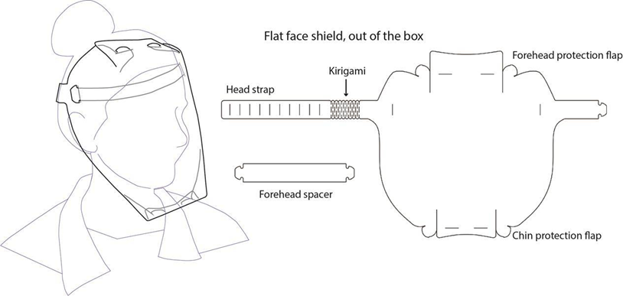

**Assembly Procedure**

1. **Fold the forehead and chin protections (x4).** To insert the tabs into their respective slots, curve shield so that the tab is on the inside and the middle flap is on the outside of the shield. Then push the tab through the slot, so that it is sticking back to the outside of the shield. In image on the right, red represents regions that should be on the inside of the shield. 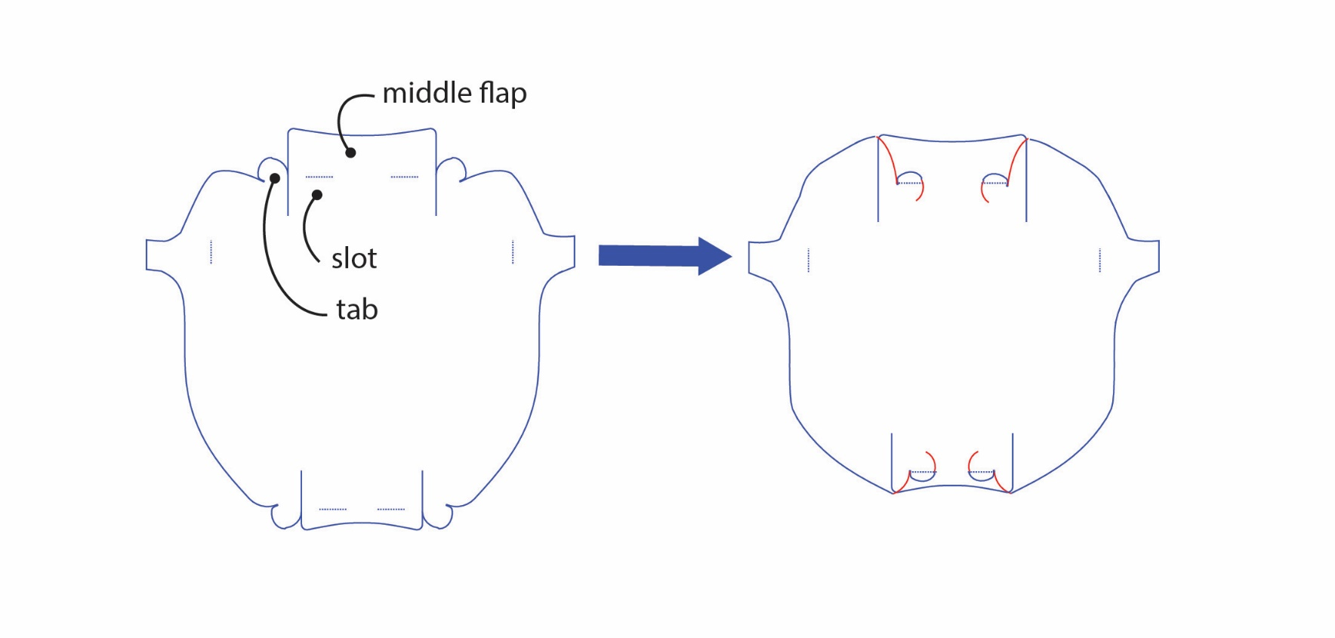
2. Insert the forehead spacer to the indicated slots by gently curving the shield and pushing the tabs through the slots:

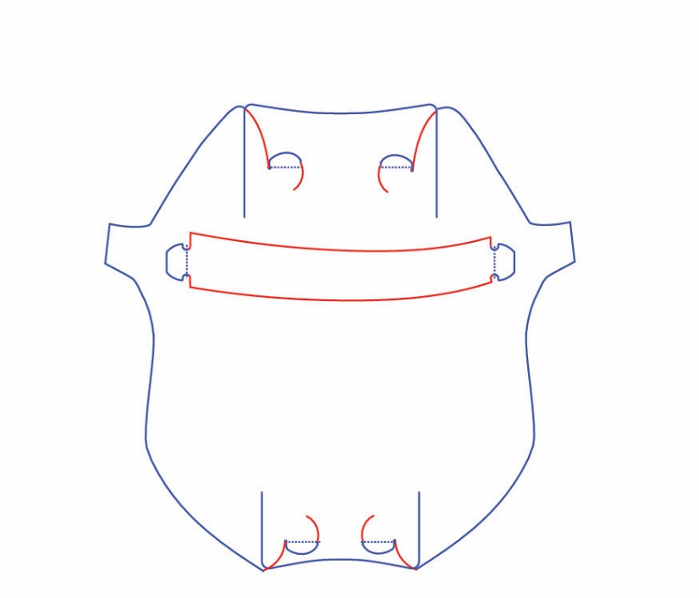

1. Adjust head strap for your size by inserting the head strap tab to the appropriate slot for your head size:
   1. For the first time use, determine the appropriate slot by placing the shield on your head before inserting the tab to any of the slots.
   2. Remember the slot for your head size for quicker donning in the future.

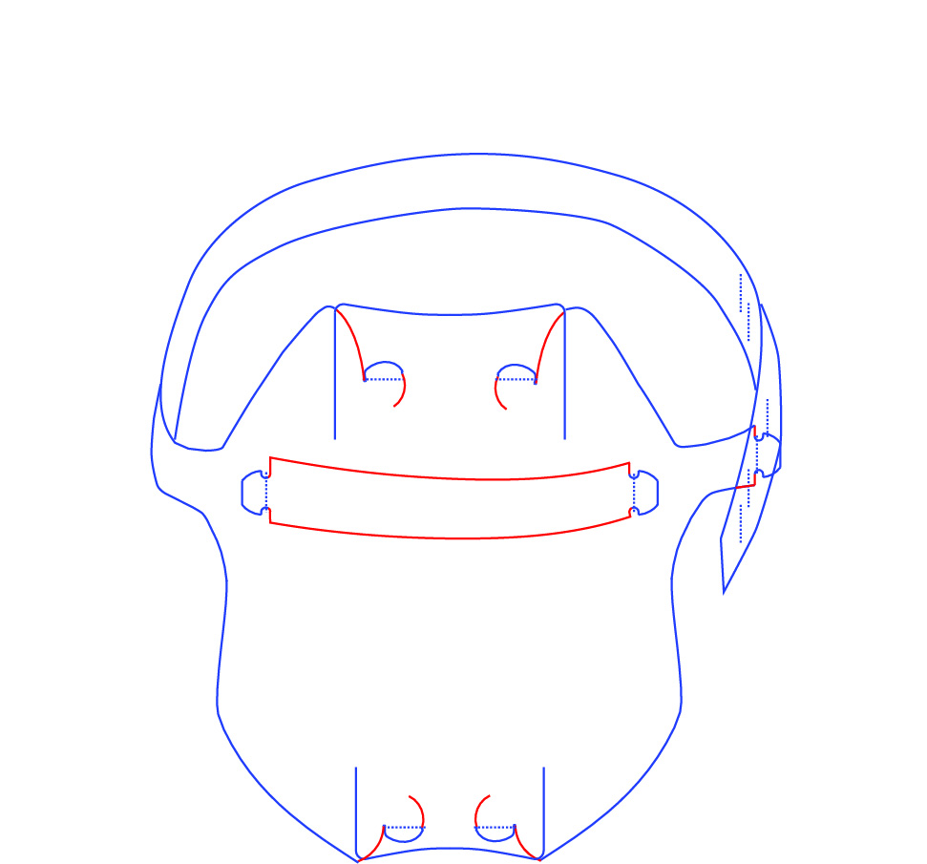

1. Don/doff using standard methods. Avoid touching your face when donning and doffing.